CREATE A FORM

DATE:10-11-2022

TEAM ID: PNT2022TMID19437

Connecting nodes using node-red:

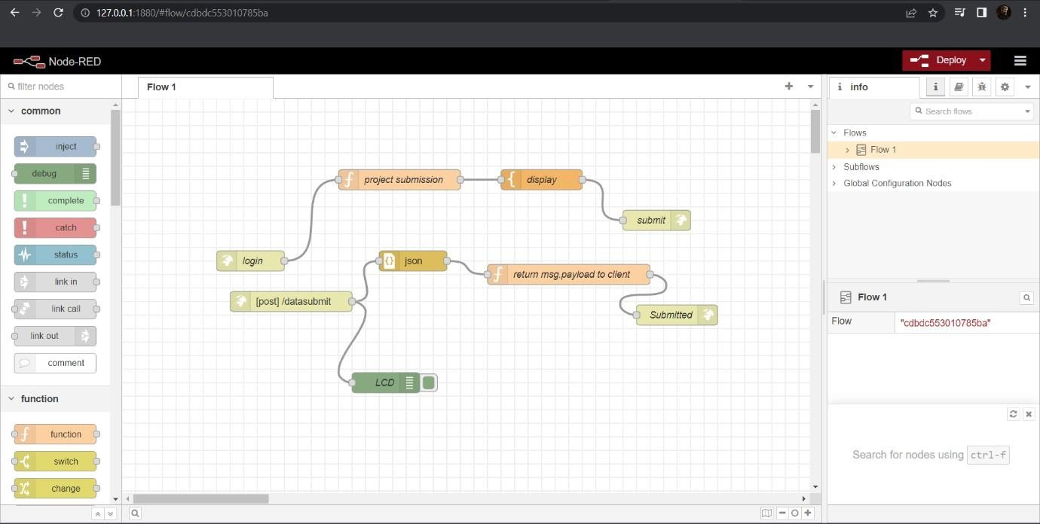

After deploying the nodes:

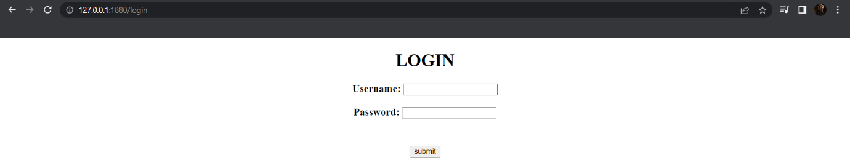

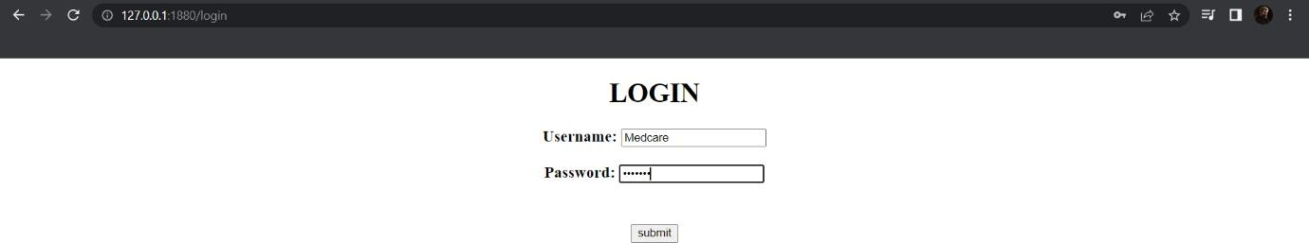

After clicking on Submit button:

